Міністерство освіти і науки України

Національний університет “Львівська політехніка”

Кафедра МКС



**Звіт**

З лабораторної роботи №4

З дисципліни: «Кросплатформні засоби програмування»

На тему:

«Інтерфейси»

Виконав: ст.гр. КІ-35

Куденчук Владислав

Прийняв:

Іванов Ю. С.

**Львів 2022**

Мета: ознайомитися з процесом розробки класів та пакетів мовою Java. 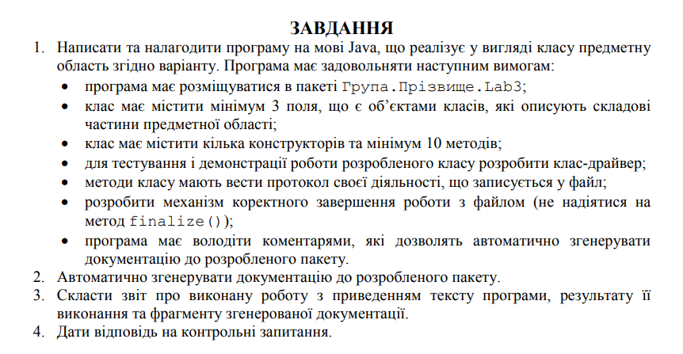



Виконання:

Код:

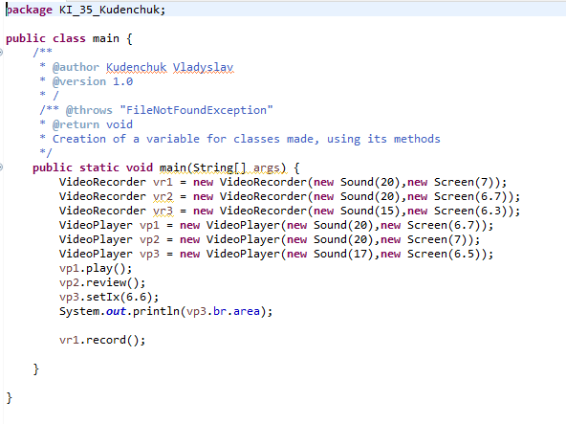

**Class VideoPlayer**

**package** KI_35_Kudenchuk;

**import** java.io.File;

**import** java.io.FileNotFoundException;

**import** java.io.PrintWriter;

**public** **class** VideoPlayer{

/**

* Creation of a file to write information

*/

**private** **static** **final** File ***dataFile*** = **new** File("log.txt");

PrintWriter pw;

{

**try** {

pw = **new** PrintWriter(***dataFile***);

} **catch** (FileNotFoundException e) {

**throw** **new** RuntimeException(e);

}

}

/**

* Creation of new objects

*/

Sound kt = **new** Sound();

Screen br = **new** Screen();

/**

* "Putting" Screen and Sound into a box

* **@param** kt

* **@param** ix

*/

**public** VideoPlayer(Sound kt, Screen br) {

**this**.kt = kt;

**this**.br = br;

}

/**

* Gets Sound variables

* **@return** kt

*/

**public** Sound getKt() {

**return** kt;

}

/**

* Sets Sound variables

* **@param** kt

*/

**public** **void** setKt(Sound kt) {

**this**.kt = kt;

}

/**

* Gets Sound variables

* **@return** br

*/

**public** Screen getIx() {

**return** br;

}

/**

* Sets Screen variables

* **@param** d

*/

**public** **void** setIx(**double** d) {

**this**.br.area = d;

}

/**

* Gets Sound variables

* **@throws** "FileNotFoundException"

*/

**public** VideoPlayer() **throws** FileNotFoundException {

}

**public** **void** play() {

System.***out***.println("VideoPlayer sounds...");

}

**public** **void** nextSong() {

System.***out***.println("start playing next song");

}

/**

* Methods that print information into file

* **@param** message

* **@throws** FileNotFoundException

*/

**protected** **void** logActivity(String message) **throws** FileNotFoundException {

pw.println(message);

pw.flush();

}

/**

* Method for display of showing and printing info in file

*

* **@throws** FileNotFoundException

*/

**public** **void** show() **throws** FileNotFoundException {

System.***out***.println("showing screen");

**try** {

logActivity("method show() was called");

} **catch** (FileNotFoundException e) {

**throw** **new** RuntimeException(e);

}

}

/**

* Method for notification of reviewing and printing info in file

* **@throws** FileNotFoundException

*/

**public** **void** review(){

System.***out***.println("reviewing case");

**try** {

logActivity("method review() was called");

} **catch** (FileNotFoundException e) {

**throw** **new** RuntimeException(e);

}

}

}

**Class Screen**

**package** KI_35_Kudenchuk;

**public** **class** Screen {

/**

* **@param** area of Screen

*/

**double** area =0;

/**

*Constructor of Screen

* **@param** area of Screen

*/

**public** Screen(**double** area) {

**this**.area = area;

}

**public** Screen() {

}

/**

* Gets the area of an Screen

*/

**public** **void** mainScreen() {

System.***out***.println("returned to main screen");

}

**public** **double** getArea() {

**return** area;

}

/**

* Sets the area of an Screen

* **@param** area of Screen

*/

**public** **void** setArea(**double** area) {

**this**.area = area;

}

}

**Class Sound**

**package** KI_35_Kudenchuk;

**public** **class** Sound {

/**

* **@param** loudness of Sound

*/

**double** loudness;

/**

*Constructor of Sound

* **@param** loudness

*/

**public** Sound(**double** loudness) {

**this**.loudness = loudness;

}

**public** Sound() {

}

**public** **void** checkSound() {

System.***out***.println("all is working fine");

}

/**

*

* **@return** loudness of Sound

*/

**public** **double** getLoudness() {

**return** loudness;

}

/**

* Sets the loudness of Sound

* **@param** loudness

*/

**public** **void** setLoudness(**double** loudness) {

**this**.loudness = loudness;

}

}

**Class VideoRecorder**

**package** KI_35_Kudenchuk;

**import** java.io.FileNotFoundException;

/**

* Creation of a variable for classes made, using its methods

* **@author** Kachur Vladyslav

* **@version** 1.0

*/

**public** **class** VideoRecorder **extends** VideoPlayer **implements** Record {

VideoPlayer a = **new** VideoPlayer(**new** Sound(35.5),**new** Screen(20));

/**

* Making default instruments military

* **@param** hk Hook

* **@param** ix IceAxe

*/

**public** VideoRecorder(Sound hk, Screen ix) {

**super**(hk, ix);

}

/**

* Default constructor of MilitaryAlpinistInventory

* **@throws** FileNotFoundException

*/

**public** VideoRecorder() **throws** FileNotFoundException {

**super**();

}

/**

* Method hide

*/

@Override

**public** **void** record() {

**try** {

a.logActivity("recording");

} **catch** (FileNotFoundException e) {

**throw** **new** RuntimeException(e);

}

System.***out***.println("recording");

}

}

**Interface Record**

**package** KI_35_Kudenchuk;

**public** **interface** Record {

**void** record();

}

Console:

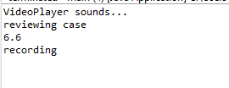

Text file:

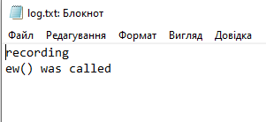

Висновок: ознайомився з процесом розробки класів та пакетів мовою Java.